**LAB – 1**

AIM – Basic Commands of Linux

Shruti Mishra

21BCP110

Div-2 G4

1) whoami - displays information about user logged into the system

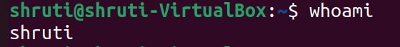

2) pwd - displays the current directory

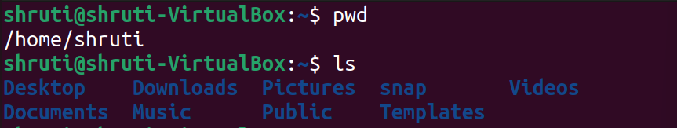

3) ls - displays the names of files or lists the content of a directory



4) ls -R -> list also files/directories which begin with a dot

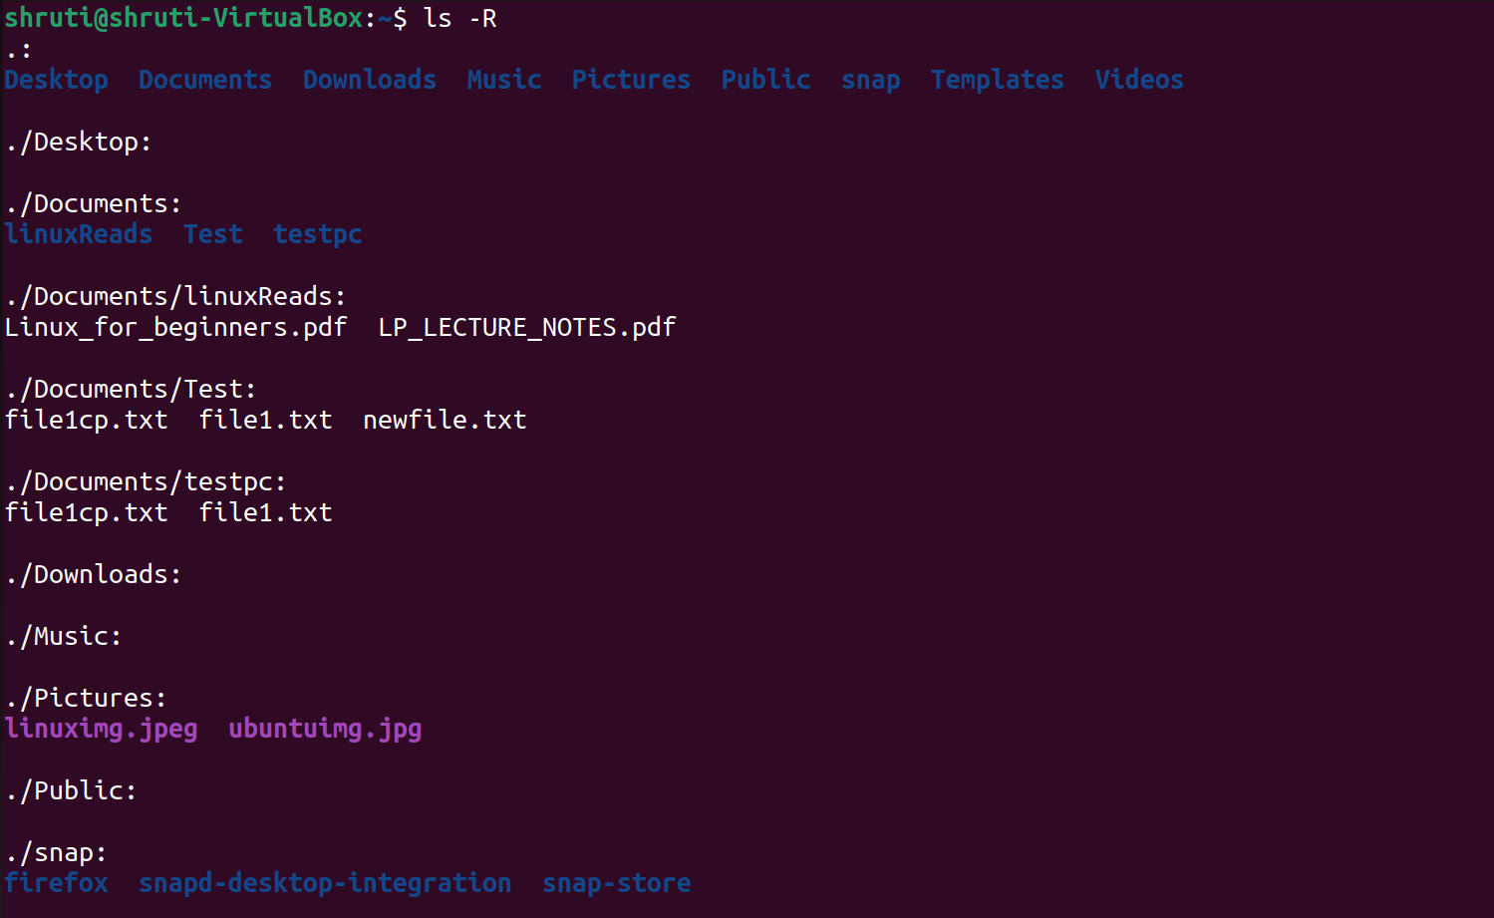

5) ls -a -> list also files/directories which begin with a dot

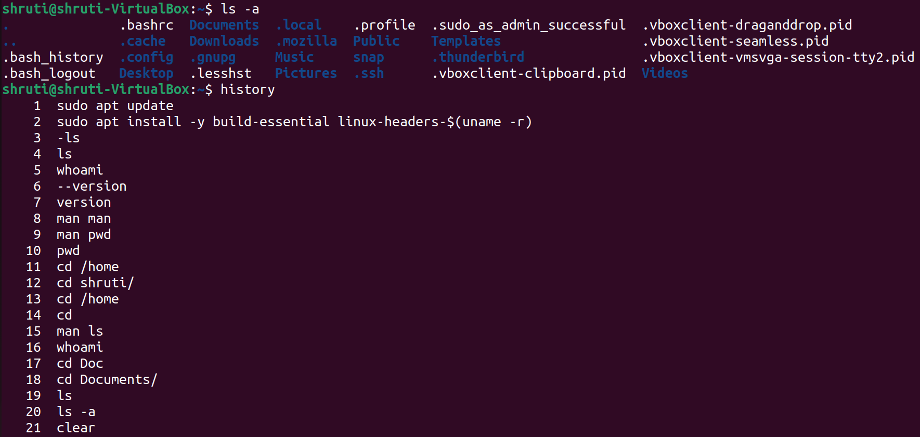

6) history - used to view the previously executed command



7) clear - clear all the previously entered commands

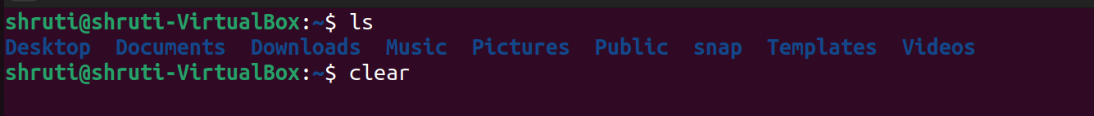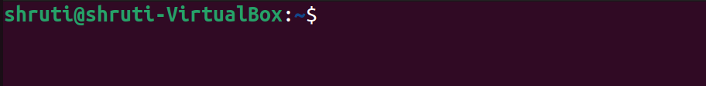

8) echo - display line of text/string that are passed as an argument

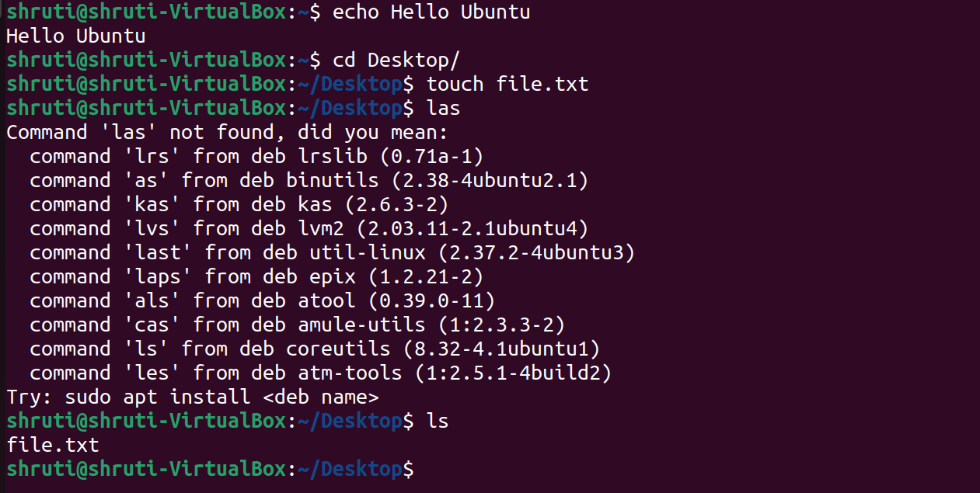

9) touch – new file created



10) rm - Delete files and/or directories





11) mkdir - creates an empty directory

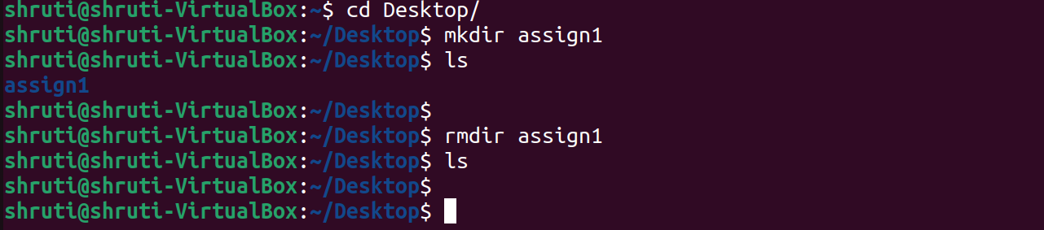

12) rmdir - deletes an empty directory



13) mv commands - Rename or move files or directories

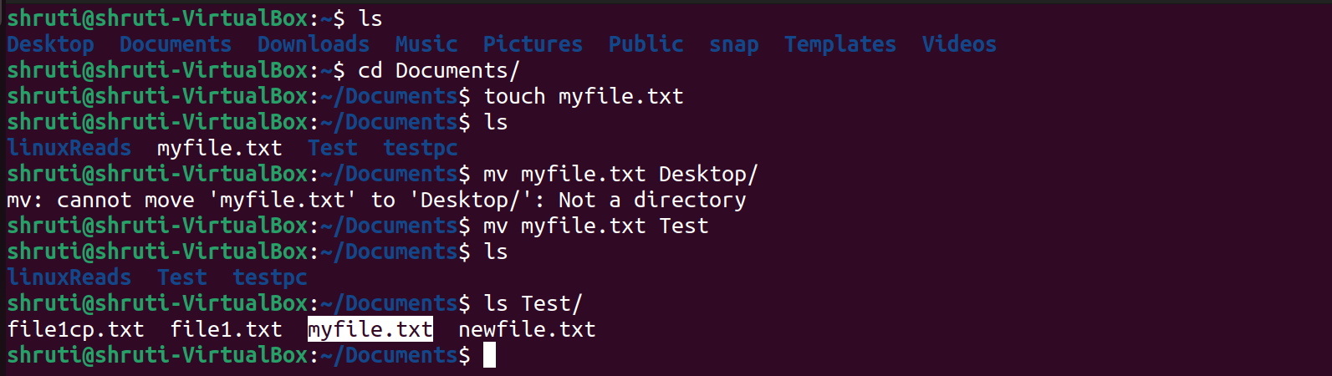

14) cd - Changes into the given directory

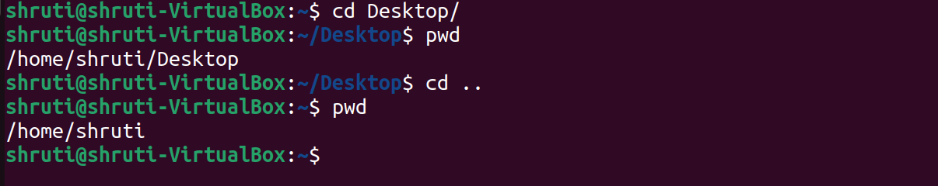

15) cmp – compare given files

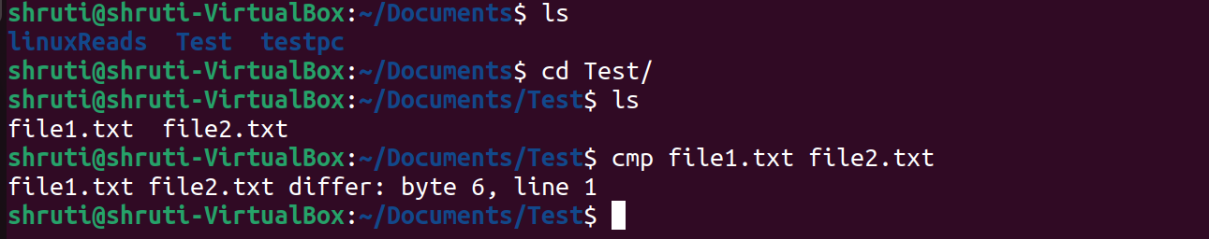

16) cat - displays the content of a file

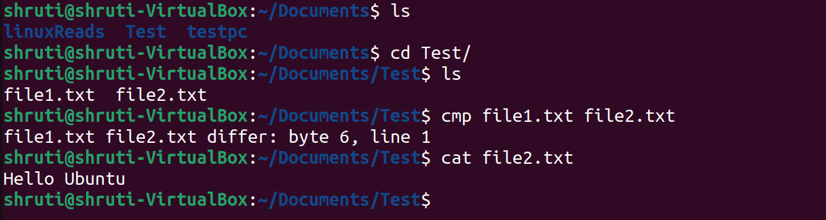

17) cal – displays calender

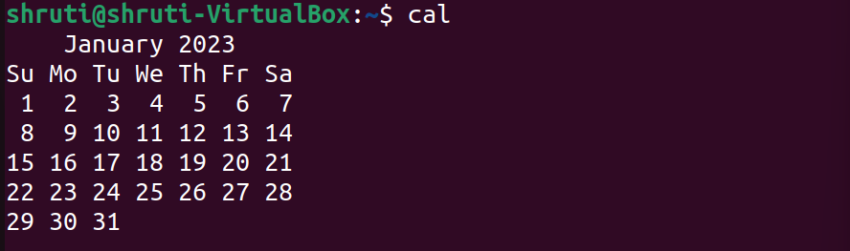

18) grep - used to search a string of characters in a file

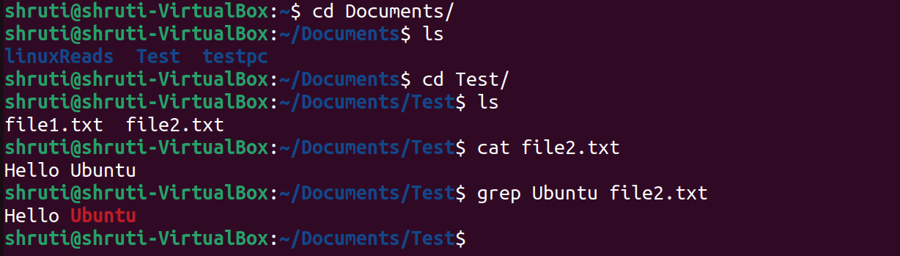

19) free - displays the amount of memory in megabytes

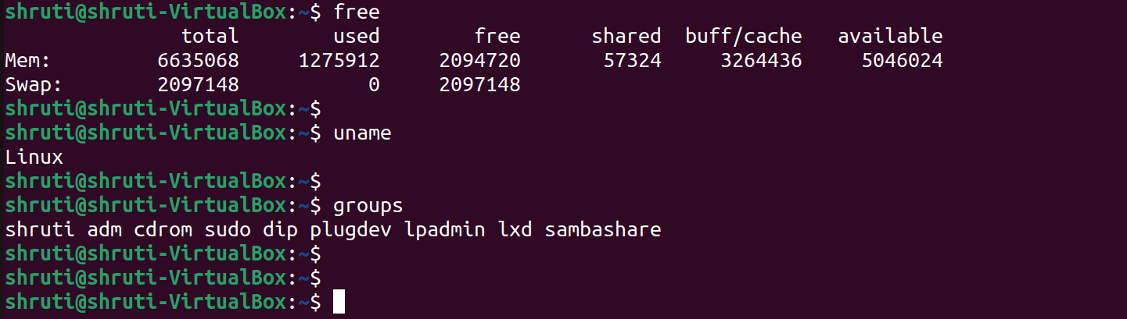

20) uname - displays the information about the system



21) groups - names of the primary and supplementary **groups** for username



22) comm – compare command

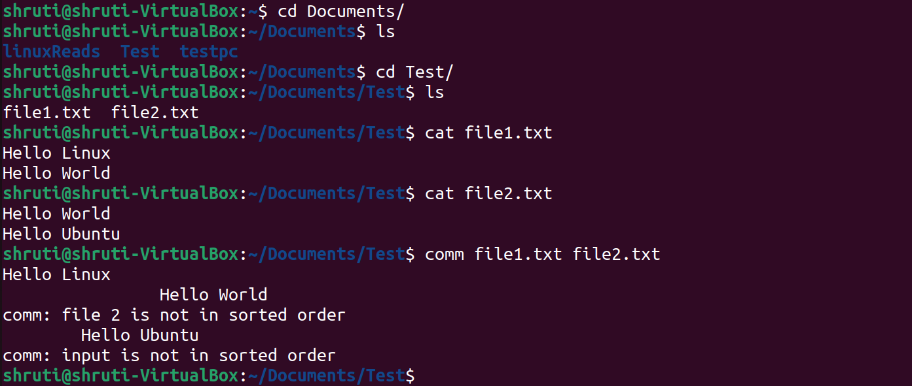

23) date - display the system date and time

